



DATA Gen™
Environment Setup Guide

Version - 1.0
10th Aug, 2012

Copyright © 2009-2012 Enterprise System Solutions (P) Ltd. All rights reserved
www.esspl.com

Contents
1 Overview Error! Bookmark not defined.
2 Eclipse Setup 3
2.1 Create a new workspace 3
2.2 Install Vaadin Plugin for eclipse Error! Bookmark not defined.
2.3 Checkout code from sourceforge svn repository 4
2.4 Project Configuration 6
2.5 Add Tomcat Server… …………………………………………………….……….7
2.6 Deploy and Run Application.…………………………………………………..….7
3 Access DataGen Application 7
4.
Conclusion …………………………………………………………………….……….7

1. Overview
In this document I will demonstrate how to setup development environment (eclipse) for DATAGen project. This contents of this document is compatible with eclipse 3.4 (Ganymede) or higher version.
Note: - Not tested with Java 7(Indigo).

2. Eclipse Setup
I assume that your system is already configured for java development. That means JDK, Eclipse, Tomcat etc. basic software’s are installed and has bean configured properly. If not first do it and then come back. Except that one more important thing is you must be an member of the DATA Gen project on Sourceforge.net in order to participate in Development. If you are interested for contributing this project, first register yourself on Sourceforge site and then contact tapas.friends@gmail.com for adding you as a member in the project.

2.1 Create a new workspace
Now let’s start our configuration. Create a new workspace folder in your file system (any name will be fine) called DataGen_WS. Then open your eclipse and browse the newly created workspace. Your workspace should be blank like below image for the first time.

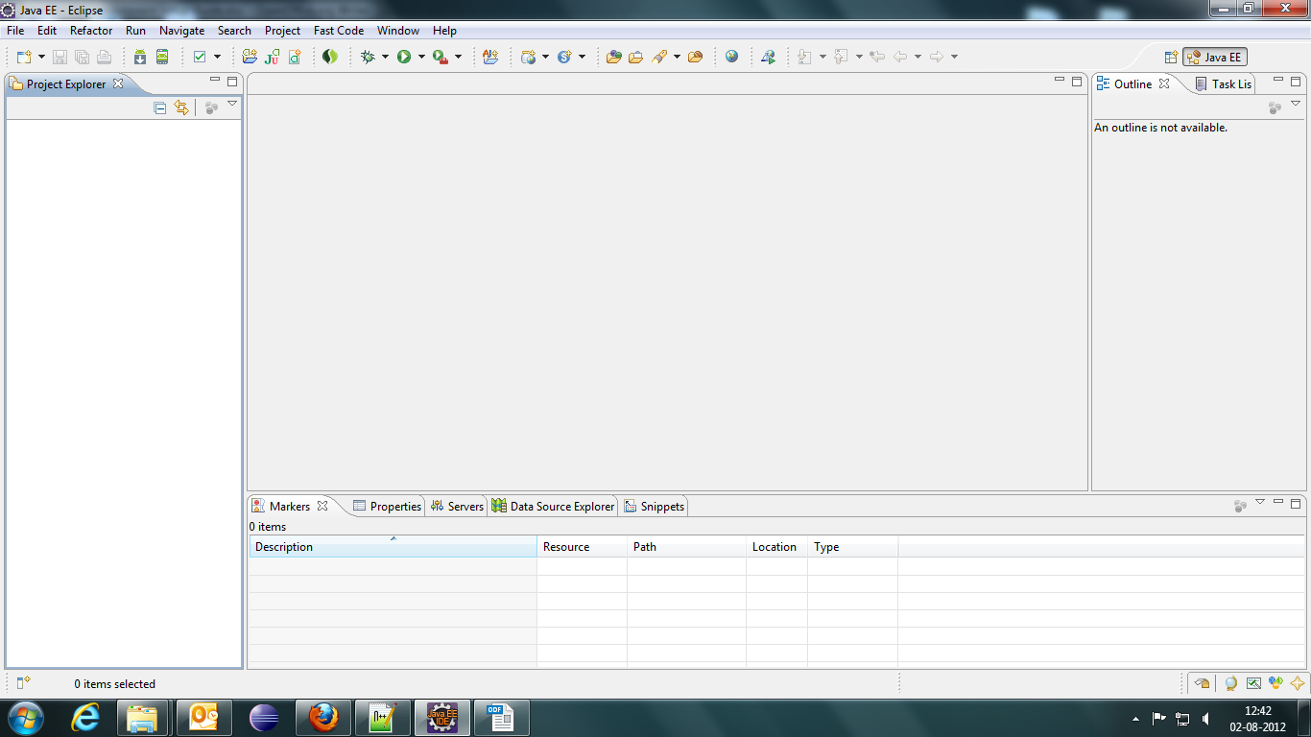
2.2 Install Vaadin Plugin for Eclipse
The easiest way to get started with Vaadin development is to install the Vaadin Plug-in for Eclipse. To install the new plug-in click on Help->Eclipse Marketplace and find "vaadin plugin for eclipse" and click on install. Follow the onscreen instructions to complete the installation and restart the eclipse after installation. For more information visit (http://vaadin.com/eclipse/).

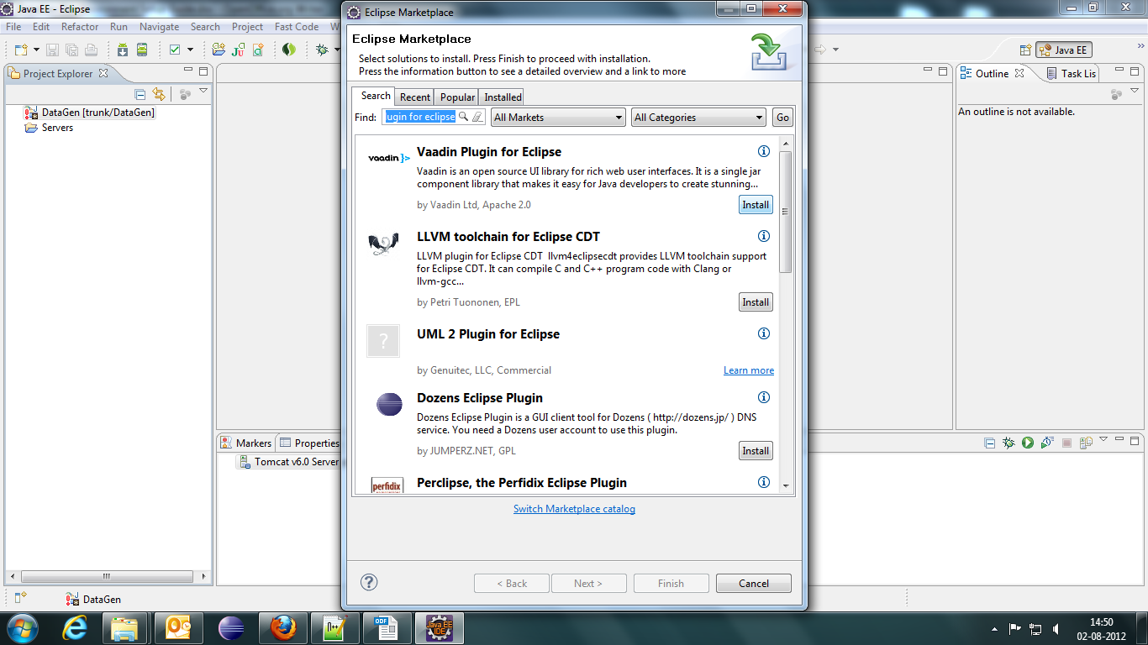

2.3 Checkout code from sourceforge svn repository
Your eclipse with new workspace and vaadin plugin is now ready. Next we have to checkout the code from Sourceforge.net svn repository. Change your eclipse perspective to "SVN Repository Exploring". Add a new repository location and use the below url for repository url and click on finish.

https://svn.code.sf.net/p/testdatagen/code/trunk

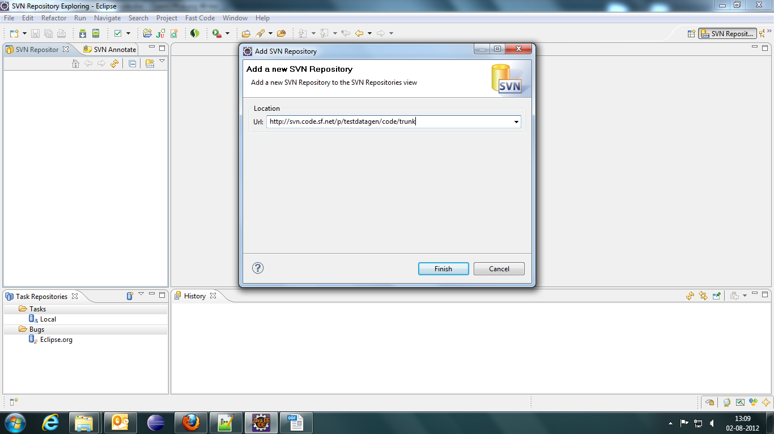

After clicking finish your new location should be added to your eclipse SVN Repository Explorer view. Then expand the tree structure by clicking on its root node. You will find DataGen folder inside that. Now right click on the DataGen folder and select Checkout from the context menu.
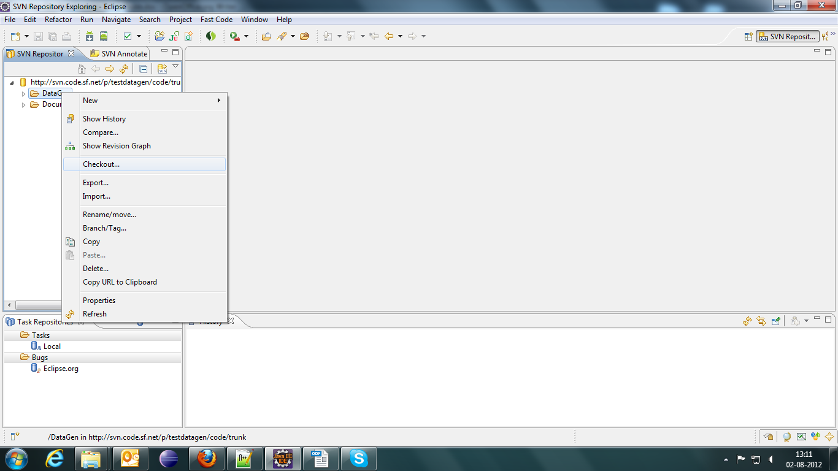

After that you will found the checkout modal. For the simplicity don't change anything from there (you can change as per your requirement). Just click on finish button.
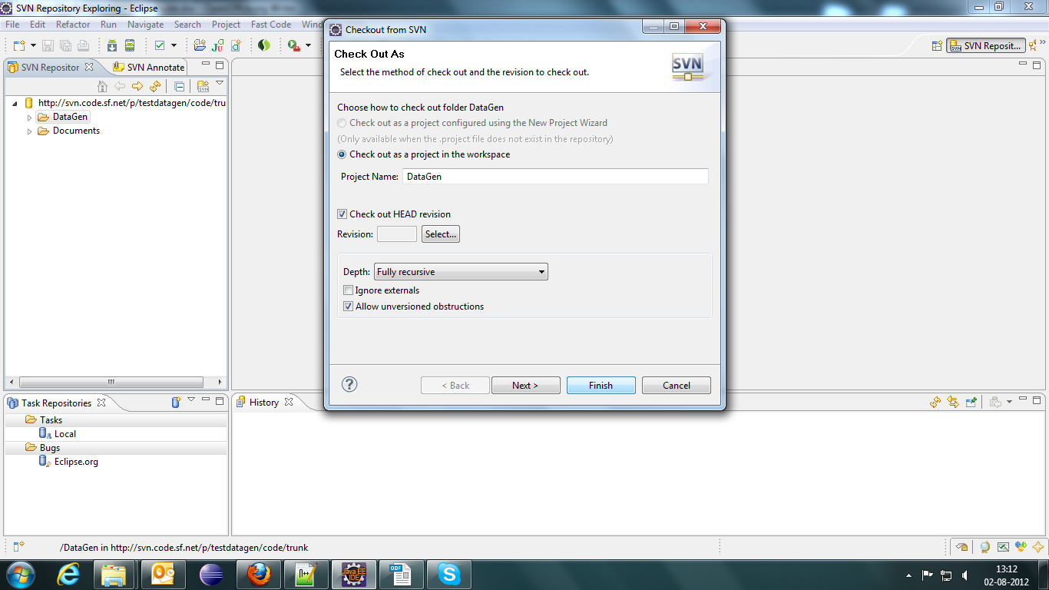
It should start check outing. After the successful completion, change the eclipse perspective to Java EE. Now you will see the DataGen project has been added to your eclipse project explorer view.

2.4 Project Configuration
You might notice there may be a red mark on project folder. That indicates your projects require some configuration changes. Now right click on project and select Build Path->Configure Build Path from the context menu. Now you should see properties modal like below and then go to Libraries tab.

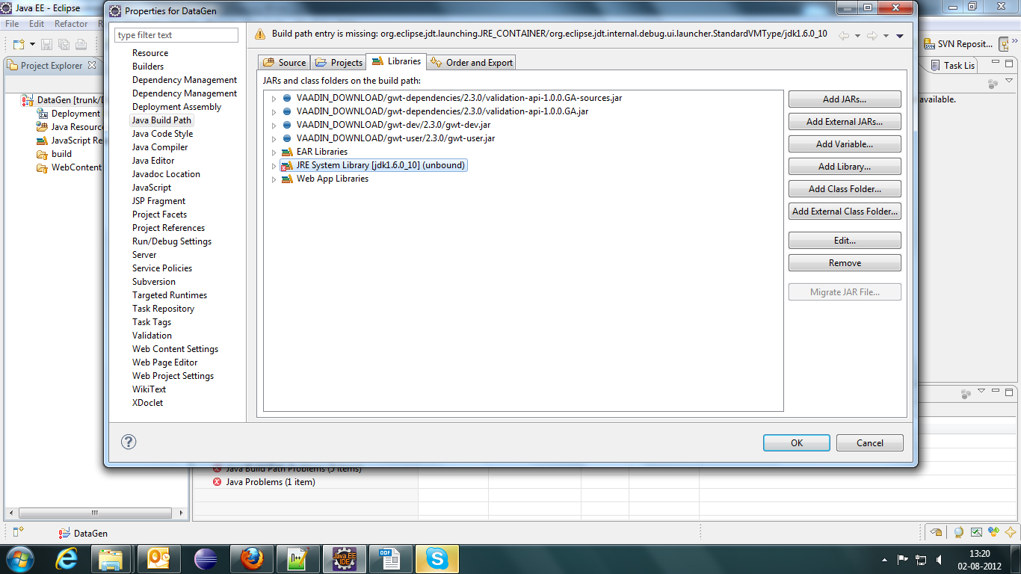
Now you might see your JDK unbound error there. Remove that and add your installed JDK instance and click on Ok button.

The next step of configuration is adding libraries from lib folder to build path. Go to DataGen->WebContent->WEB-INF->lib and select all the jar files. Right click and select Build Path->Add to build path option.
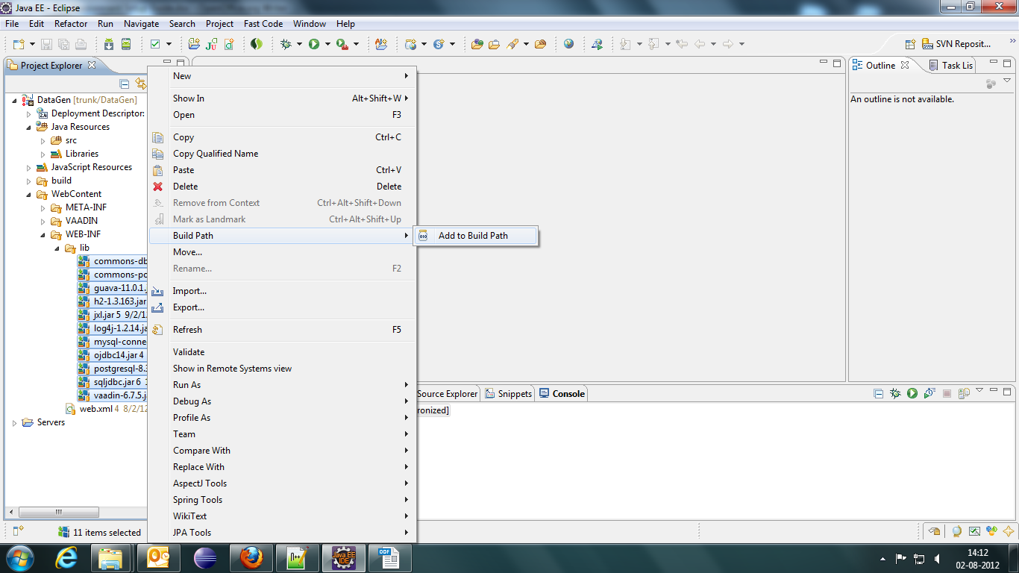

2.5 Add Tomcat Server
Add a server to your eclipse. If not already done, do it first.

2.6 Deploy and Run Application
To run the application right click on project and select Run As->Run on Server. Then add it to server and click on finish.

3. Access DataGen Application
Open your browser and hit the below url.
http://localhost:<port>/DataGen

4. Conclusion
For any further query please contact tapas.friends@gmail.com

